Order Of Service

Singing: Psalm 72—CW page 93

Reading: Psalm 82

Opening Hymn: TLH 422

Reading: Acts 13:42-52

Request Hymn: CW Supplement 750

Reading: Matthew 2:19-23

Sermon Hymn: TLH 421

Sermon Text: Mark 1:16-20

Down By The Sea

Prayer

The Apostles’ Creed, TLH page 12

Holy Communion

The Lord's Prayer

The Blessing

Closing Hymn: TLH 416

* * * * * * * * * * *

Koinonia Hour

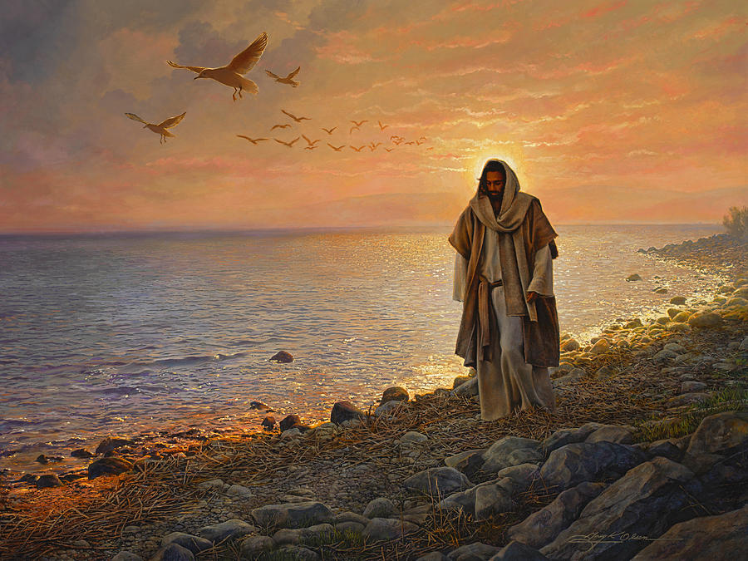

Down By The Sea

Water
Of
Life

7 October 2018

W A T E R O F L I F E

Independent Christian Church—Conservative Lutheran Doctrine

Worship Service: 9:30 a.m. Bible Study: 10:45 a.m.

Larry Cooper, Pastor E-Mail address:
111 N. Ridge Road lcooper@wateroflife.cc
Coon Valley, WI 54623 Web Site:
Phone: (608) 452-2105 www.wateroflife.cc

* * * * * * * * * * * * * * * * * * * * * * * * * * *

Sermon Text: Mark 1:16-20

Down By The Sea

* * * * * * * * * * * * * * * * * * * * * * * * * * *

Mark 1:16 Now as he walked by the sea of Galilee, he saw Simon and Andrew his brother casting a net into the sea: for they were fishers.
:17 And Jesus said unto them, Come ye after me, and I will make you to become fishers of men.
:18 And straightway they forsook their nets, and followed him.
:19 And when he had gone a little further thence, he saw James the son of Zebedee, and John his brother, who also were in the ship mending their nets.
:20 And straightway he called them: and they left their father Zebedee in the ship with the hired servants, and went after him.

